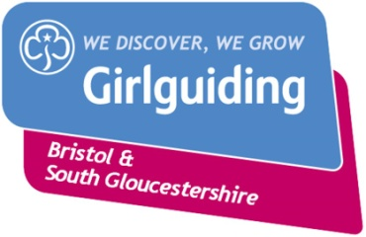
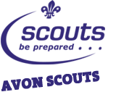
Bristol Monopoly Run
14th May 2022

Have you got what it takes to successfully move around the monopoly board to score your team valuable points?
Using your navigational skills, work as a team to visit the sites of Bristol.
Join other guides, scouts, senior section, explorers, network members and leaders on a giant scale monopoly game in May.

When? 14th May 2022
Where? In and Around Bristol
Cost? £10.00 each (includes event badge, end of event BBQ and prizes (if you do really well!))

If you would like to take part in the Bristol Monopoly Run please fill in the below slip and return to your unit leader with £10 (xxxx) by xxxx

Name:

Would like to take part in the Bristol Monopoly Run, enclosed is £10 for the event.

Signed: Date:

